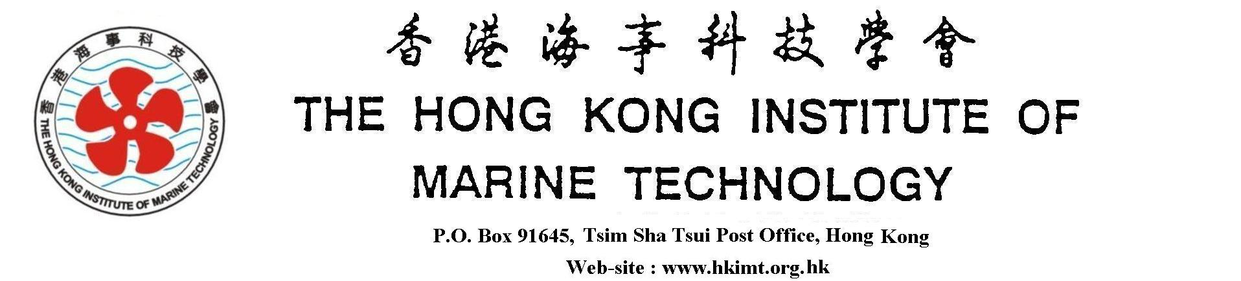

Hon President: Mr. David C.C. Koo Hon. Vice-President: Mr. Francis Law
Chairman: Mr. Alan C.M. Tsang Hon. Secretary: Dr. K.S. Fung

Date:

To: Hon. Secretary of HKIMT
Email Address : Secretary@hkimt.org.hk

Fm:
HKIMT Member Number (if applicable) :
Email Address:
Phone:
Order Form for HKIMT Souvenior/Gift items
No | Particular | Unit Price (HKD) | Quantity | Amount (HKD) | Remarks
1 | HKIMT Plaques | $ 200.- |  | If
2 | HKIMT Beer Mugs | $ 40.-
3 | HKIMT Ties | $ 100.-
 |  |  | Total: ……………
Price is excluded the delivery charge and you are requested to collect from the Hon. Secretary at the convenient time and place mutually agreed.
Cheque shall be made payable to the Hong Kong Institute of Marine Technology for the total order amount upon collection.

